Martin, Alison, “Benjamin Degen illustrates how ‘Where We Live’ becomes a part of one’s identity,” The Examiner, 26 October 2015.



Benjamin Degen illustrates how 'Where We Live' becomes a part of one's identity

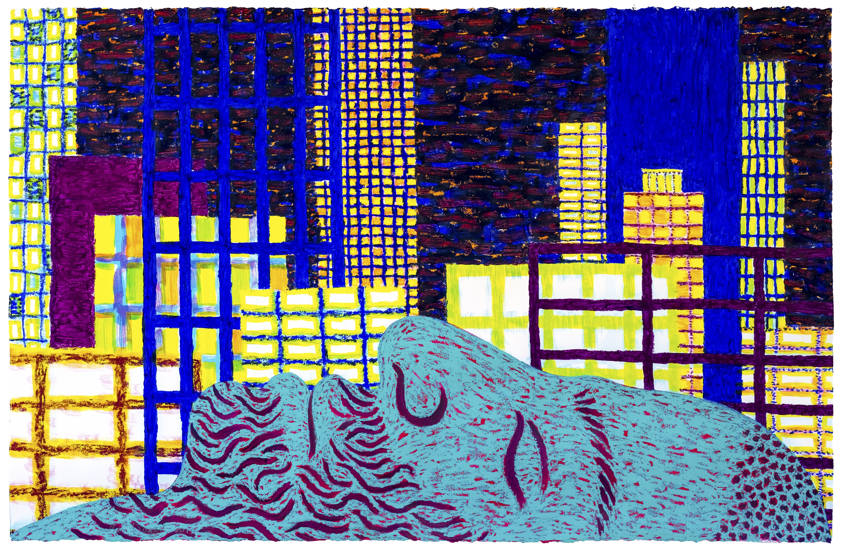‘The Susan Inglett Gallery in Chelsea is currently presenting a collection of work by Benjamin Degen for an exhibition titled Where We Live. As the title of the show suggests, Degen offers several paintings where he examines the different relationships that individuals and groups of people have with the place they call home and how it becomes part of their character.

The inspiration behind these works came when Degen came back to New York City after having lived elsewhere for three and a half years and barely recognized the city he once knew. Many of his old neighborhood haunts were gone, yielding to tall luxury buildings making him feel somewhat out of place. He describes his fond memories of his friends and neighbors as “ghosts [being] whited out by new glass buildings that didn’t know them or leave much room for memory.”

Degen references the story of Rip Van Winkle in the pieces *Rip* Van and New Construction, and Dawn. Rip Van depicts the head of a man sleeping just as Washington Irving’s protagonist did, while in New Construction, the man’s arm can be seen as he’s pointing to several new, tall buildings in front of him that weren’t there when he went to sleep. Dawn features a woman sleeping in a simple, familiar environment with several colorful trees waiting to greet her as she arises.

Similarly, a piece titled Birdillustrates an indigo colored bird flying across the center of the image with a skyline of some small buildings revealing a dark sky. However in Migration, the bird plus another bird behind it can be seen flying south as more and more tall buildings rise up behind them.

Other notable works include portraits of individuals in the comfort of their homes and neighborhood haunts such as with Park, featuring a young man walking his dog with a soccer ball behind him, and Drawing, Drinking, Sleeping, Dreaming depicting a couple sleeping on their bed side by side with a table containing a pencil, paper, and a can and bottle of beer. Degen also includes still-lifes of porcelain pottery with Chinese designs such as with Fragile Box illustrating a vase inside a cardboard box, Plant in Dragon Pot featuring a flower pot resting on a windowsill with images of dragons and clouds on the side, and Ming depicting an urn about to fall over with a black cat lurking behind with bright, green eyes.

At **[The Susan Inglett Gallery](http://www.inglettgallery.com/" \t "_blank)**, 522 W. 24th St., through Dec. 5. The gallery is open Tues.—Sat. from 10 a.m.—6 p.m.